Customer Segmentation and Clustering Analysis
K-Means and Hierarchical Clustering of Hotel Bookings in Python

Week 3 Task | Hotel Booking Demand Dataset

Prepared by: Abhishek Pal
Computer Science Engineering (Data Science), ABES Engineering College
September 2026

1. Introduction and Objectives
Not every guest is worth the same to a hotel, and not every guest behaves the same way. Segmentation groups bookings that behave alike so that pricing, marketing and operations can be tailored instead of averaged. This report applies unsupervised learning (K-means, validated against Ward hierarchical clustering) to real hotel booking records to find distinct guest groups and to translate them into strategy.
Objective | Where addressed
Identify a hospitality dataset with behavioural and demographic fields | Section 2
Engineer and justify features | Section 3
Implement clustering, choose the number of clusters and validate | Sections 4-5
Interpret segments and derive strategy | Sections 6-7
Report challenges, limitations and future work | Sections 8-9

2. Dataset
The Hotel Booking Demand dataset (Antonio, Almeida & Nunes, 2019) is used again, in the cleaned form produced in Week 1 (87,221 bookings from a city hotel and a resort hotel in Portugal, 2015-2017; duplicates, empty-guest records and price outliers already removed).
Important caveat: the data has no guest identifier, so each row is a booking, not a unique customer. The segments below are therefore segments of booking behaviour. A returning guest may appear in more than one segment, and the 'repeat guest' flag is the only link to loyalty.

3. Feature Engineering and Selection

3.1 Features used
Feature | Type | Construction and reason
lead_time | Behavioural | Days between booking and arrival (log-transformed); planning horizon
total_nights | Behavioural | Weekend + week nights (log-transformed); length of stay
total_guests | Demographic | Adults + children + babies; party size
adr | Value | Average daily rate, winsorised at the 99.5th percentile; price paid
total_of_special_requests | Behavioural | Engagement and service expectations
booking_changed | Behavioural | 1 if the booking was modified at least once
has_children | Demographic | 1 if children or babies are in the party
is_repeat | Loyalty | Repeat guest flag from the source data
prior_cancel | Risk | 1 if the guest has cancelled before
weekend_share | Behavioural | Weekend nights divided by total nights; leisure vs business pattern

3.2 Features deliberately excluded
- is_canceled (the outcome): kept out of the model so it can be used afterwards to test whether the segments differ in a business-relevant way.
- Parking (required_car_parking_spaces): removed after a first run showed a data-leakage problem. Every one of the 7,306 bookings that used parking was not cancelled (0% cancellation versus 30% for the rest), because the field is only recorded for stays that happened. Leaving it in would have let the outcome leak into the segments, and one sub-segment was in effect just 'parking users'. This is a good example of why feature meaning must be checked before modelling.
- Categorical fields such as market segment, deposit type, meal plan, country and hotel type: not used as inputs because K-means relies on Euclidean distance. They are used afterwards to describe the segments (Section 6).

3.3 Transformations
Lead time and total nights were right-skewed (skewness 1.43 and 2.95), so a log(1+x) transform was applied (skewness after: -0.72 and 0.22). A log transform was tried on ADR too but made it worse (skewness went from 0.88 to about -3.6) because some stays have a rate of zero; winsorising at the 99.5th percentile was used instead (skewness 0.76). All features were then standardised to mean 0 and standard deviation 1 so that no variable dominates the distance calculation.
X = df[FEATS].copy()
for c in ['lead_time', 'total_nights']:
X[c] = np.log1p(X[c])
X['adr'] = X['adr'].clip(upper=X['adr'].quantile(0.995))
Xs = StandardScaler().fit_transform(X)

4. Choosing the Number of Clusters
Four internal validity measures and a stability test were computed for k = 2 to 10 on the full dataset (silhouette on a random sample of 15,000 bookings for speed).
k | Inertia | Silhouette | Calinski-Harabasz | Davies-Bouldin | Stability (ARI)
2 | 742,052 | 0.335 | 15,298 | 1.333 | 1.00
3 | 639,892 | 0.364 | 15,833 | 1.206 | 0.61
4 | 561,670 | 0.229 | 16,074 | 1.519 | 0.85
5 | 496,269 | 0.211 | 16,517 | 1.384 | 0.84
6 | 450,892 | 0.205 | 16,299 | 1.338 | 0.54
7 | 398,258 | 0.230 | 17,298 | 1.232 | 0.76
8 | 368,578 | 0.221 | 17,024 | 1.242 | 0.97

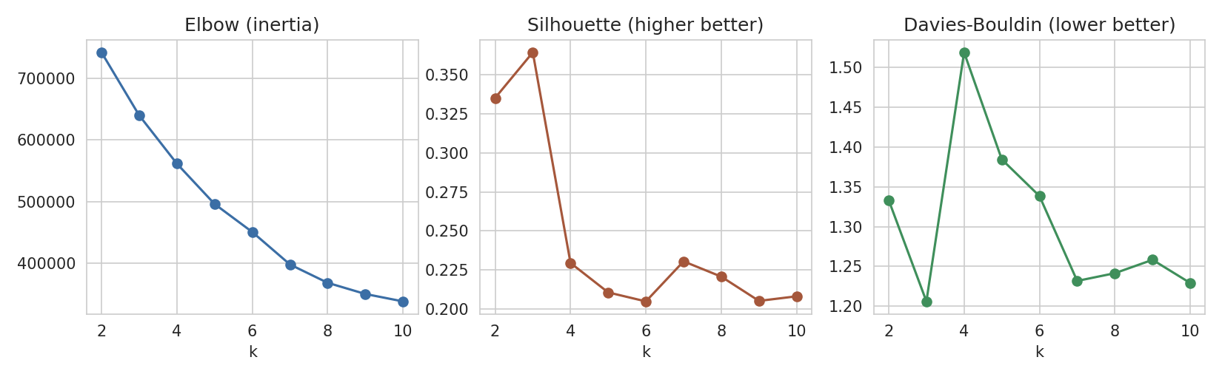
Figure 1. Elbow, silhouette and Davies-Bouldin scores for k = 2 to 10.
How to read these: higher silhouette, higher Calinski-Harabasz and lower Davies-Bouldin are better. Stability is the adjusted Rand index (ARI) between K-means solutions fitted on two different random halves of the data and applied to all bookings; 1 means identical groupings.
- k = 3 has the highest silhouette (0.364) and the lowest Davies-Bouldin score (1.206). Beyond k = 3 the silhouette falls sharply to about 0.2, meaning clusters begin to overlap.
- The elbow curve declines gradually with no sharp bend, which is typical for real behavioural data and is why it was not used on its own.
- Stability for k = 3 (0.61) is lower than for k = 2 (1.00) and k = 4-5 (0.84-0.85), so the exact boundary of the large segment shifts a little between samples. This is a real weakness and is discussed in Section 8.
Decision: k = 3 is used as the primary segmentation because it is best on silhouette and Davies-Bouldin and is confirmed by hierarchical clustering (Section 5). Because one segment contains 85.8% of bookings, a second-level drill-down of that segment is added in Section 6.4.

5. Clustering Implementation and Validation
km = KMeans(n_clusters=3, n_init=25, random_state=42).fit(Xs)
df['cluster'] = km.labels_

silhouette_score(Xs[sub], km.labels_[sub])
calinski_harabasz_score(Xs, km.labels_)
davies_bouldin_score(Xs, km.labels_)

hc = AgglomerativeClustering(n_clusters=3, linkage='ward').fit(Xs[hs])
adjusted_rand_score(hc.labels_, km.labels_[hs])

Measure | K-means (k = 3) | Interpretation
Silhouette (15,000 sample) | 0.364 | Modest: 0.26-0.50 is the 'weak structure' band of the Kaufman-Rousseeuw guide, so clusters overlap somewhat
Calinski-Harabasz | 15,833 | Higher is better; used to compare k values
Davies-Bouldin | 1.206 | Lower is better; best of all k tested
Silhouette, same 6,000 sample: K-means / Ward | 0.366 / 0.366 | Two algorithms give equally good separation
ARI, Ward vs. K-means | 0.955 | Near-identical groupings; the structure is not an artefact of K-means

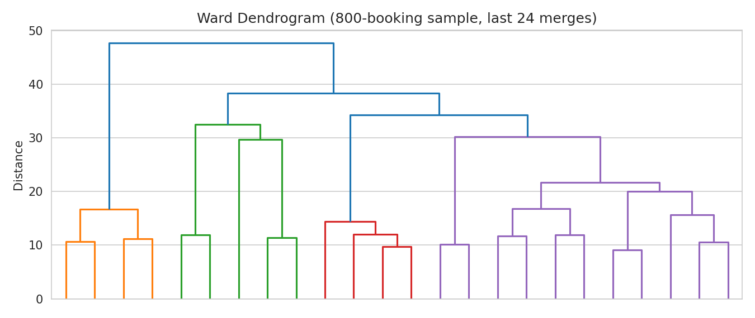
Figure 2. Ward dendrogram (800-booking sample). Three groups are visible before the large jumps in merge distance.
Ward clustering was run on a 6,000-booking sample because its memory cost grows with the square of the sample size. Agreement of 0.95 between two different algorithms is the strongest evidence in this report that the three-segment structure is not an artefact of one method, although it does not make the segments sharply separated.
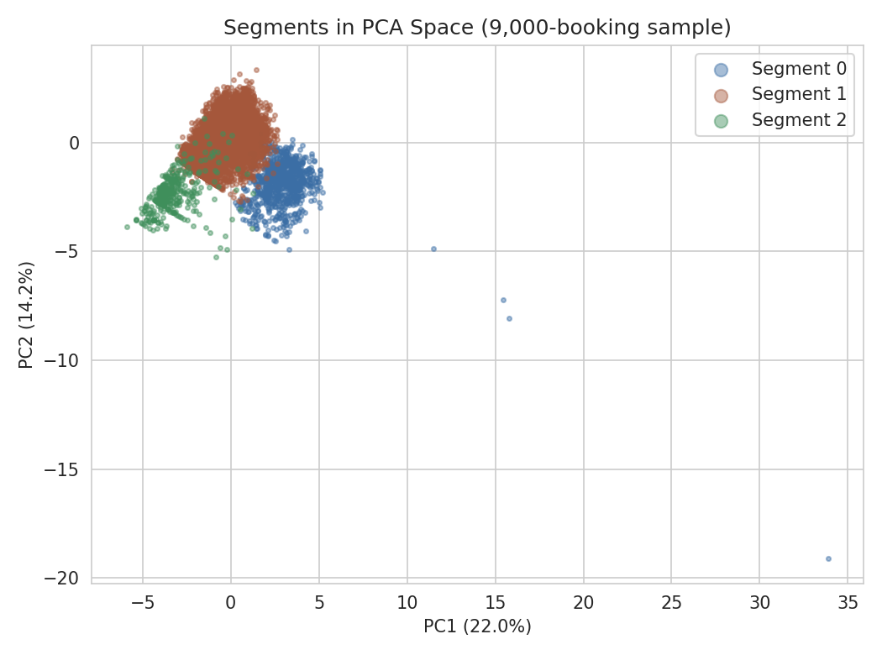
Figure 3. Segments projected onto the first two principal components (22% and 14.2% of variance).
The two-dimensional PCA view captures only 36% of the total variance, so overlap in the plot understates separation in the full feature space. Its purpose is illustration, not proof.

6. Segment Profiles
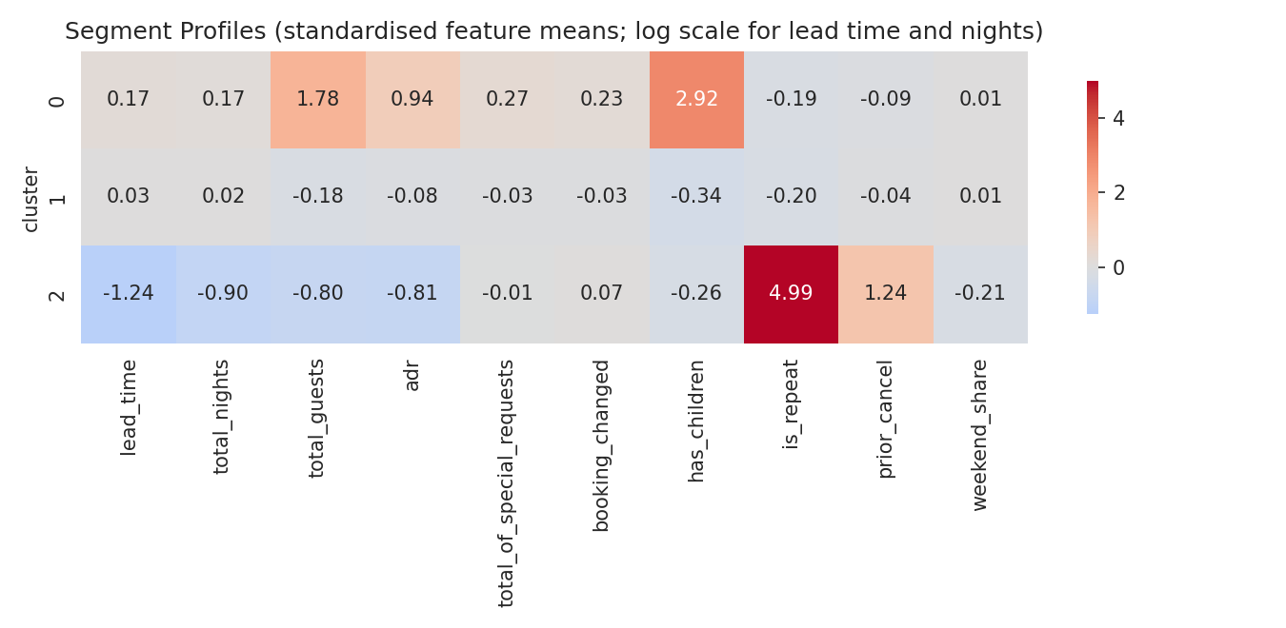
Figure 4. Standardised feature means per segment (red = above average, blue = below).

6.1 Summary table
Metric | 0: Families | 1: Mainstream Leisure | 2: Loyal Short-Stay Regulars
Bookings (share) | 9,051 (10.4%) | 74,818 (85.8%) | 3,352 (3.8%)
Median lead time (days) | 63 | 52 | 3
Median stay (nights) | 3 | 3 | 1
Mean guests per booking | 3.44 | 1.89 | 1.39
Median ADR | 149.6 | 96 | 65
Mean special requests | 0.93 | 0.67 | 0.69
Bookings with children | 100% | 0% | 3%
Repeat guests | 0% | 0% | 100%
Cancellation rate | 34.6% | 27.6% | 7.8%
Revenue proxy per non-cancelled booking | 559.9 | 354.2 | 147.9
Share of revenue proxy | 14.4% | 83.6% | 2%
Top booking channels | Online TA 71%, Direct 19% | Online TA 60%, Offline TA/TO 17% | Corporate 43%, Direct 23%
Main origin (country) | Portugal 30%, Spain 12% | Portugal 29%, UK 13% | Portugal 84%
The revenue proxy is ADR multiplied by nights for non-cancelled bookings; it excludes meals, extras and taxes, so it indicates relative room-revenue contribution only.

6.2 Segment descriptions
Segment 0 - Families (10.4% of bookings). Every booking includes children or babies. Parties average 3.44 guests, the highest rate of any segment (median ADR 149.6), and requests are the most numerous, at 0.93 per booking. They plan well ahead, change bookings more often (27%) and are mostly reached through online travel agencies. Their cancellation rate is high (34.6%), but each completed booking is worth the most (559.9).
Segment 1 - Mainstream Leisure (85.8% of bookings). Adults without children, staying a median 3 nights at a mid-level rate of 96, booking about 52 days ahead. This is the core business, producing 83.6% of the revenue proxy, but it is also the least distinctive segment; it sits near the average on almost every feature, and its cancellation rate (27.6%) is close to the overall figure.
Segment 2 - Loyal Short-Stay Regulars (3.8% of bookings). All are repeat guests. They book about 3 days ahead, stay a median of 1 night at a low rate (median 65), are 84% Portuguese, and the largest channel is Corporate (43%). They cancel least (7.8%) but 19% have cancelled before, so a prior cancellation does not make them unreliable. They contribute only 2% of revenue proxy, though their behaviour points to business travellers and local returning guests.

6.3 Business value
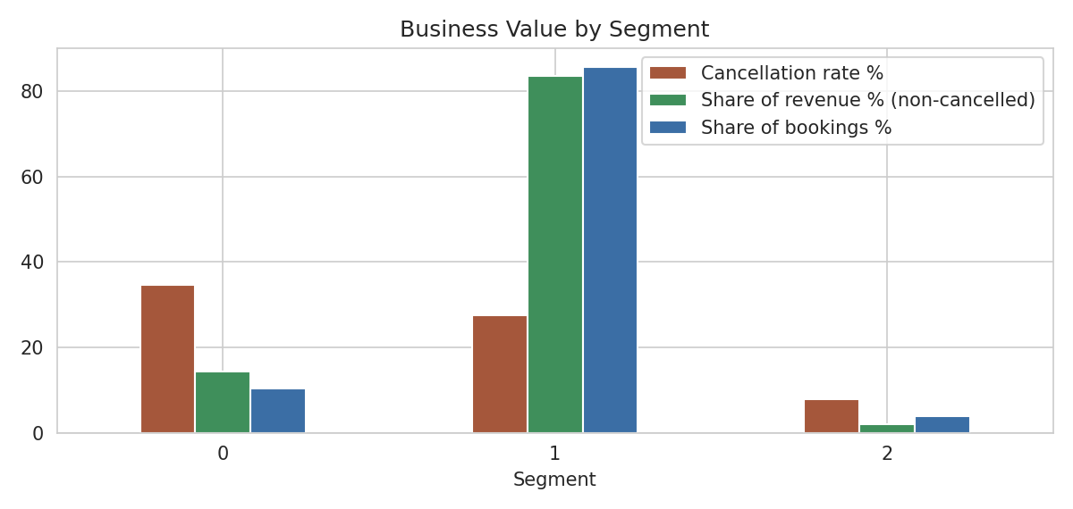
Figure 5. Share of bookings, cancellation rate and revenue share by segment.
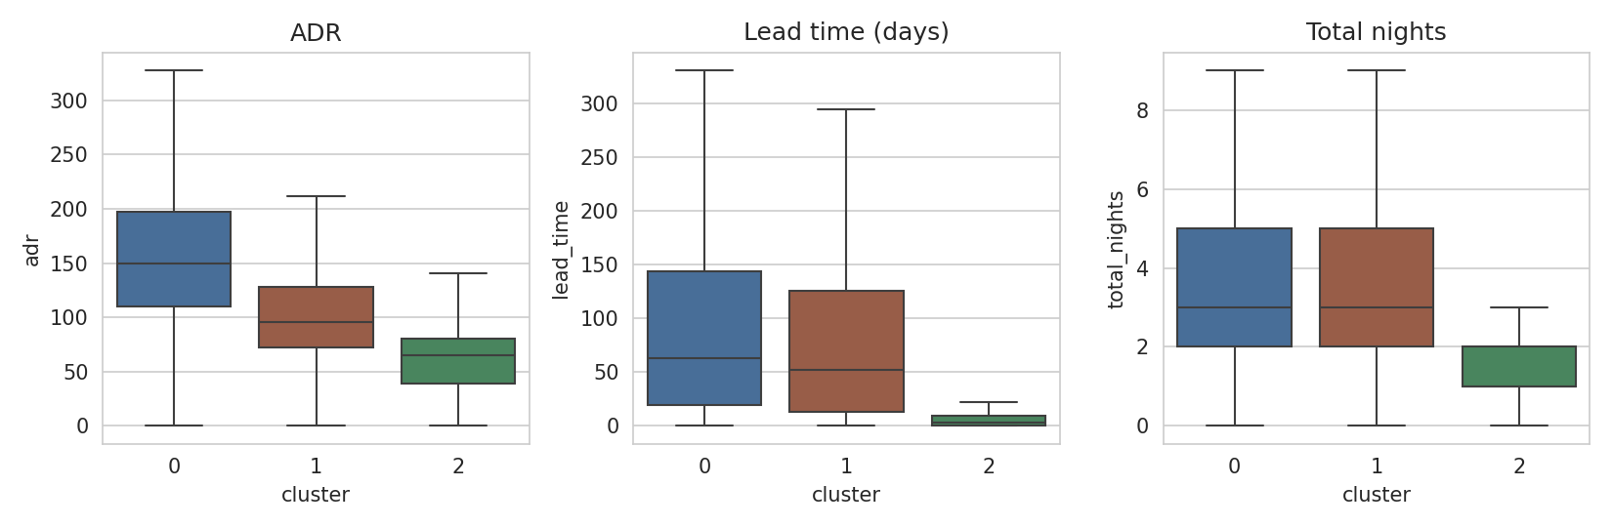
Figure 6. ADR, lead time and length of stay by segment (outliers hidden).

6.4 Drill-down: splitting the Mainstream Leisure segment
Because Segment 1 holds 85.8% of bookings, its features were re-clustered on their own (k = 3; the silhouette scores for k = 2, 3 and 4 were 0.192, 0.216 and 0.206). This gives three sub-groups:
Metric | 1a: Early planners | 1b: Last-minute short stays | 1c: Mid-horizon
Share of all bookings | 49.2% | 22.5% | 14.1%
Median lead time (days) | 84 | 5 | 68
Median nights | 4 | 1 | 3
Median ADR | 103.5 | 82.8 | 94.2
Cancellation rate | 35.3% | 18.2% | 15.6%
Share of total revenue proxy | 55.6% | 10.3% | 17.7%
Booked via Online TA | 68.6% | 50% | 43%

Reading the table: the largest sub-group plans about 12 weeks ahead, stays longest and cancels most (35%), so it drives most revenue and most cancellation risk at the same time. The last-minute group (median 5 days' notice) is cheaper, stays a median of one night and cancels less. Note that the drill-down silhouette scores are only about 0.2, so these sub-groups are tendencies on a continuum rather than sharply separated clusters.

7. Strategic Implications
Segment | Strategy | Rationale from the data
Families | Package offers (family rooms, half-board, kids' amenities); flexible-change policies; direct-booking incentives to reduce OTA dependence | Highest ADR and revenue per booking; most special requests and modifications; 71% via Online TA
Mainstream Leisure - early planners | Non-refundable or partially prepaid rates and reminder emails for long-lead bookings; modest overbooking allowance | Longest lead time, 35% cancellation, over half of the revenue proxy
Mainstream Leisure - last minute | Dynamic pricing and upsell of add-ons at booking; target with short-notice promotions in low-demand periods | Short notice, one-night stays, lower cancellation
Loyal Short-Stay Regulars | Corporate rates and loyalty benefits; fast rebooking; early-access offers | Repeat, mostly corporate, 7.8% cancellation, dependable base demand though low revenue

Cross-cutting points: (1) cancellation risk should be managed per segment rather than with one hotel-wide overbooking figure; (2) the family segment is the most valuable per booking and the most exposed to intermediary commissions; (3) loyalty is concentrated in a small segment, so the retention opportunity is large if repeat behaviour can be grown.

8. Challenges and Limitations
Issue | Effect and handling
Data leakage (parking field) | Detected and removed after a first run gave a segment with exactly 0% cancellation (Section 3.2)
Skewed and zero-inflated variables | Log transform for lead time and nights; ADR winsorised because a log transform worsened its skew
Binary features under K-means | has_children and is_repeat standardise to very large values (2.9 and 5.0 in Figure 4), so they largely define two of the three segments. K-means with binary inputs is a compromise; K-prototypes or Gower distance with hierarchical clustering would treat mixed data more properly
No guest ID | Segments describe bookings, not people; the same person may appear in several segments
One dominant, weakly distinct segment | 85.8% of bookings sit in one cluster near the average; the drill-down helps, but its sub-groups overlap (silhouette about 0.2)
Modest cluster quality | Silhouette 0.364 sits in the weak-structure band (0.26-0.50) of the Kaufman-Rousseeuw guide; real behaviour changes gradually rather than falling into separate groups, so segments are useful simplifications, not natural categories
Stability at k = 3 | ARI 0.61 across resamples: the exact boundary of the large segment is not fixed
Revenue proxy | Room revenue only; does not include meals, extras, commissions or discounts
Age and geography of data | Two Portuguese hotels, 2015-2017; results may not carry over to other markets or to current behaviour

9. Recommendations and Future Work
- Adopt the three-segment view for strategy communication and the drill-down for pricing and cancellation policy.
- Re-run with a mixed-data method (K-prototypes, or Gower distance with Ward linkage) and compare against these results.
- Test Gaussian mixture models, which allow overlapping segments and give soft membership probabilities.
- Track segment size, cancellation rate and revenue share over time; re-fit periodically and re-check stability.
- Link bookings to guest IDs, and add spend on extras and stay-level feedback, so that customer lifetime value can be segmented instead of booking behaviour.
- Validate the strategies through controlled tests (for example a deposit policy for early-planner bookings) before rolling them out.

10. Conclusion
Ten booking features were engineered, cleaned of a data-leakage risk, transformed and clustered. K-means with three clusters gave the best internal validity, and an independent Ward clustering reproduced the same grouping almost exactly (ARI 0.95). The segments are Families, Mainstream Leisure, and Loyal Short-Stay Regulars, with a further split of the mainstream group by planning horizon. They differ meaningfully in price, planning behaviour, cancellation risk and revenue contribution, which supports segment-specific pricing, cancellation and loyalty strategies. The main cautions are modest cluster separation, one very large mainstream segment, and booking-level rather than guest-level data.

References
Antonio, N., de Almeida, A., & Nunes, L. (2019). Hotel booking demand datasets. Data in Brief, 22, 41-49.
Hubert, L., & Arabie, P. (1985). Comparing partitions. Journal of Classification, 2(1), 193-218.
Pedregosa, F., et al. (2011). Scikit-learn: Machine learning in Python. Journal of Machine Learning Research, 12, 2825-2830.
Kaufman, L., & Rousseeuw, P. J. (1990). Finding Groups in Data: An Introduction to Cluster Analysis. Wiley.
Rousseeuw, P. J. (1987). Silhouettes: A graphical aid to the interpretation and validation of cluster analysis. Journal of Computational and Applied Mathematics, 20, 53-65.
Ward, J. H. (1963). Hierarchical grouping to optimize an objective function. Journal of the American Statistical Association, 58(301), 236-244.

